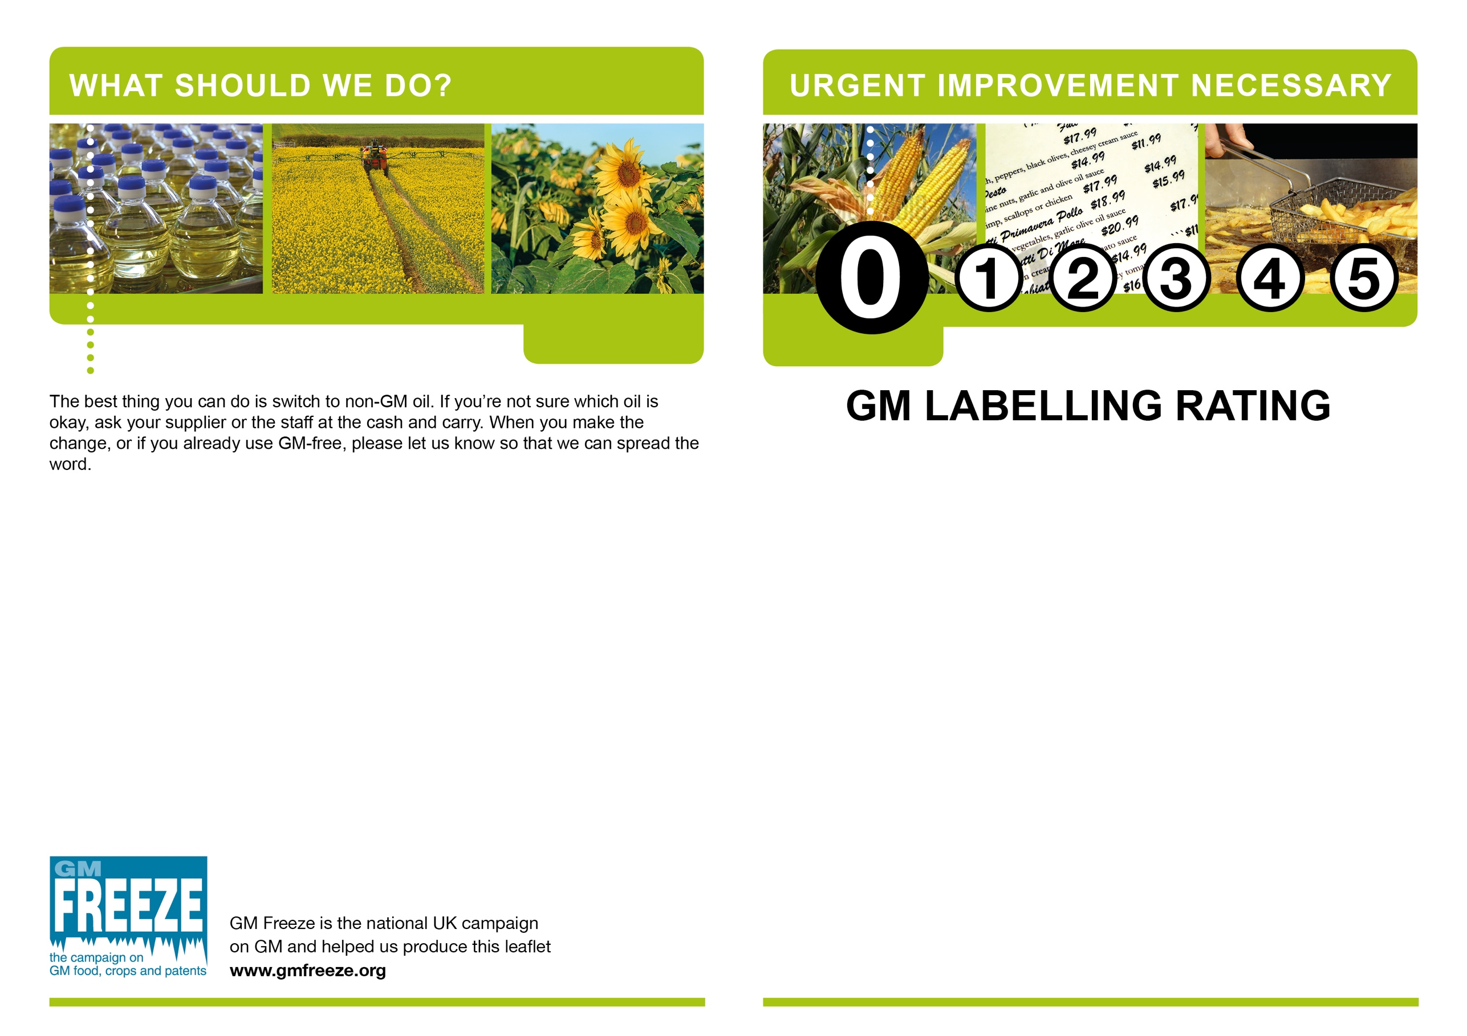

ADD YOUR CONTENT HERE: If you are doing anything to encourage those using GM-free (eg listing GM-oil free businesses on your website or contacting the local press) mention it here. It’s okay to leave this space blank, but remember to delete these instructions. This text is set in Arial Regular 10 point and fits a maximum of 344 characters, 80 words (including spaces).

ADD YOUR CONTENT HERE: If you are working to a list of specific target businesses, you could include their details here or delete this text and add each business’s details with stickers. Alternatively, you may want to include your group’s name and a few words of introduction here, for example:

*GM Free Borsetshire is contacting business in Ambridge and Penny Hassett to help them understand and comply with the law. We want to celebrate local businesses that are using non-GM cooking oil and will list them on our website at* [*www.XXXXXXXX.org*](http://www.XXXXXXXX.org)*.*

This text is set in Arial Regular 10 point and fits a maximum of 700 characters, 160 words (including spaces).

ADD YOUR CONTENT HERE: Include your group name and contact information here, even if it is already listed elsewhere on the leaflet.

This text is set in Arial Regular 10 point and fits a maximum of 344 characters, 80 words (including spaces).

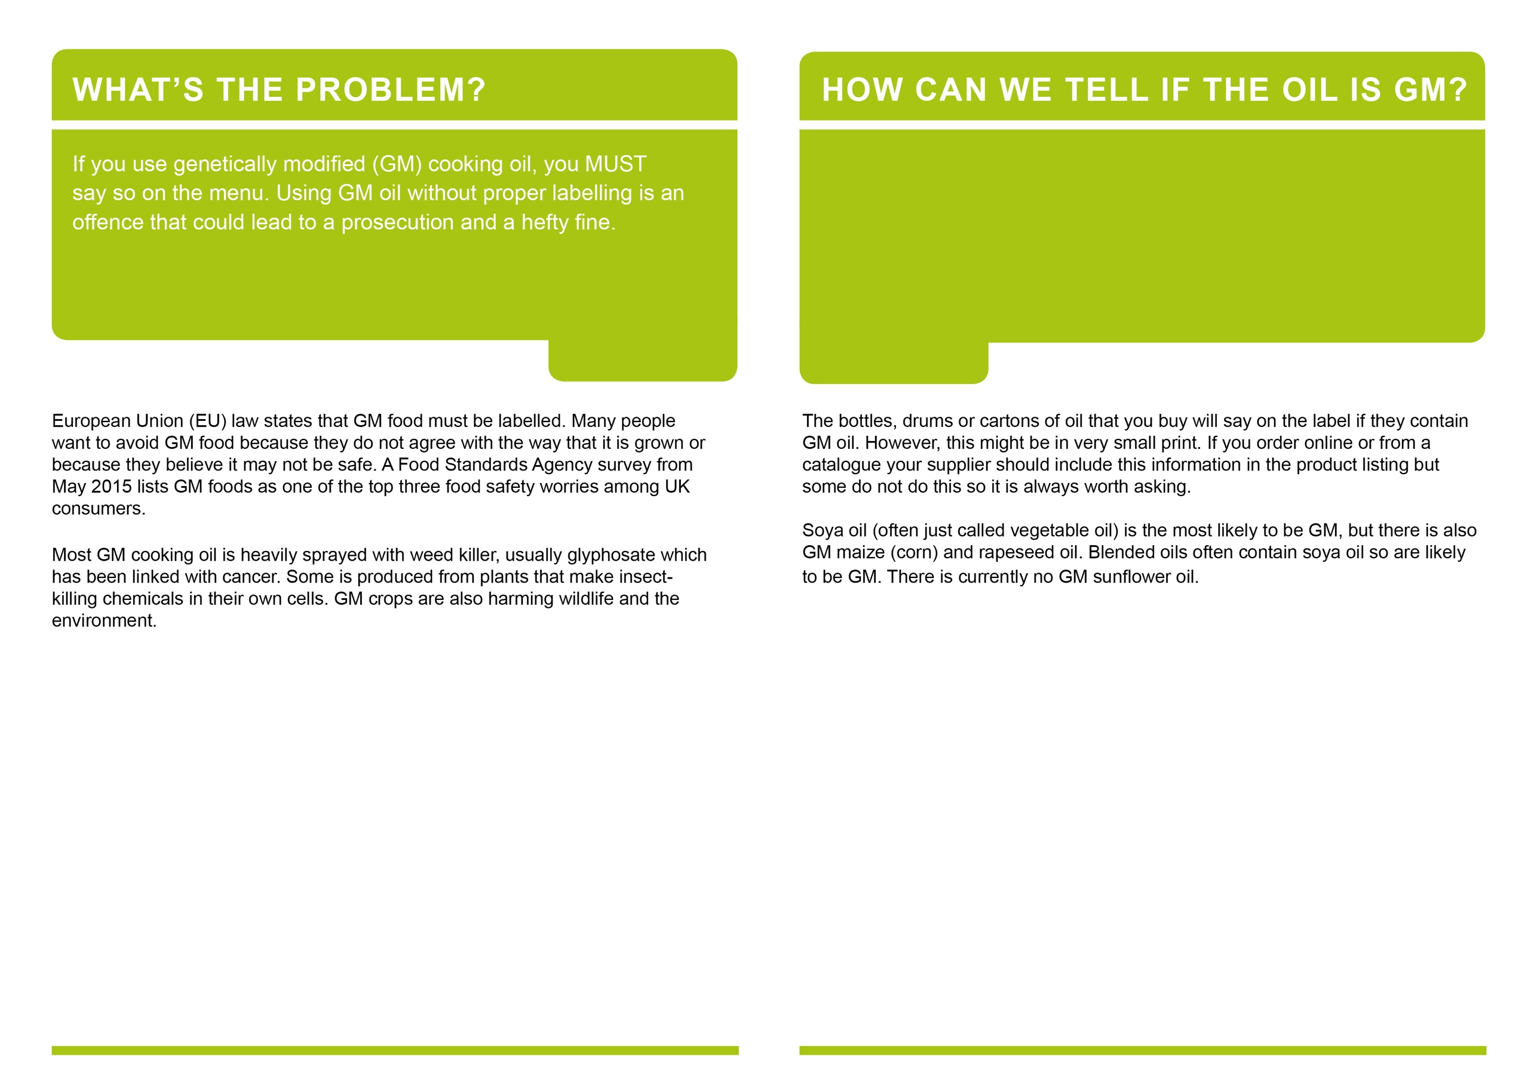

ADD YOUR CONTENT HERE:

If you have any information about local sources of GM-free cooking oil that is suitable for use by caterers, it would be good to include them here, eg brands of GM-free frying oil stocked at local cash and carry outlets.

If you don’t have anything to add here, it’s okay to leave this space blank, but remember to delete these instructions!

This text is set in Arial Regular 10 point and fits a maximum of 1,190 characters, 215 words (including spaces).

ADD YOUR CONTENT HERE: This is the place to say something about the local situation. GM labelling is a Food Standards issue which means it is usually dealt with by Trading Standards. However, in Scotland, Northern Ireland and some local authorities in England and Wales, it comes under Environmental Health. Your campaign will have more credibility if you get the local details right. For example:

*A GM Free Borsetshire survey revealed that some businesses in Penny Hassett are using GM cooking oil but not indicating this on the menu. We would rather work with you to help you do the right thing, but we will report you to Trading Standards if necessary.*

This text is set in Arial Regular 10 point and fits a maximum of 877 characters, 160 words (including spaces).